Professor Paul Neve, Weed ecology & evolution, Department of Plant & Environmental Sciences, University of Copenhagen.

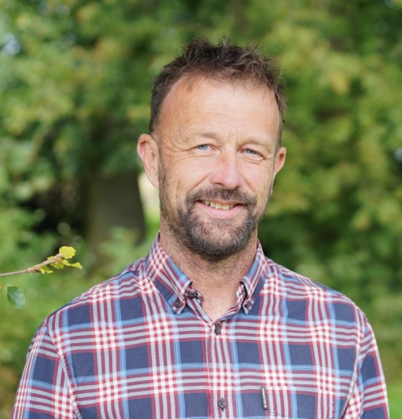
After a PhD at the University of Liverpool in the UK, Paul spent six years from 1999 with the Australian Herbicide Resistance Initiative (AHRI) where he explored the ecology, evolution and management of herbicide resistance in ryegrass. He returned to the UK in 2005 to take up a role at the University of Warwick where he was awarded a Faculty position in 2009. Paul moved to Rothamsted Research in 2014 to lead the weed ecology group. In 2017 he became the lead scientist for Rothamsted’s programme in Smart Crop Protection. He moved to the University of Copenhagen in 2020 to take a Professorship. In Copenhagen his group have been exploring the ecological, evolutionary and genomic basis of weediness, and crop-weed-microbe interactions. A large, new “One Crop Health” project commencing in 2024, seeks to integrate approaches from ecology, agronomy, data sciences and modelling to explore new crop protection systems with reduced reliance on pesticides.

